UNIT IV: Clustering

Clustering is an unsupervised ML technique that involves grouping a set of data points into clusters such that points in the same cluster are more similar to each other than to those in other clusters. It is used to discover inherent structures or patterns in data without predefined labels.
- Groups data based on similarity/distance measures.
- Does not require labeled data.
- Helps in summarizing and understanding large datasets.

Partitioning Clustering is a type of unsupervised learning method where the dataset is divided into a set of non-overlapping subsets or clusters, such that each data point belongs to exactly one cluster.
Feature | Description
Type | Flat clustering (non-hierarchical)
No of clusters (k) | Must be specified before the algorithm starts
Data point membership | Each data point belongs to exactly one cluster
Objective | Minimize intra-cluster distance and maximize inter-cluster distance
Common Algorithms | K-Means, K-Medoids, CLARANS

Working of Partitioning Clustering (Using K-Means as an Example):
- Initialization: Randomly select k data points as initial centroids.
- Assignment Step: Assign point to nearest centroid, forming k clusters.
- Update Step: Compute centroids by taking mean of points in a cluster.
- Repeat: Repeat assignment and update steps until convergence.

Advantages: Simple and fast for small to medium-sized datasets, efficient when clusters are spherical and of similar size.

Disadvantages: Requires prior knowledge of k (number of clusters), Sensitive to the initial choice of centroids. Not suitable for clusters with complex shapes or varying sizes.
Criteria | Hierarchical Clustering | K-Means Clustering
Type | Hierarchical (tree-based) | Partition-based (flat clustering)
Cluster Structure | Dendrogram representing nested clusters | Divides data into k non-overlapping flat clusters
Input Required | No need to specify number of clusters beforehand | Must predefine number of clusters k
Approach | Agglomerative (bottom-up)/Divisive (top-down) | Iterative refinement (assignment + update)
Visualization | Dendrogram (tree structure) | No hierarchical structure is formed
Computational Complexity | Higher: O(n²) or O(n³), less efficient for large datasets | Lower: O(nki), faster for large datasets
Flexibility in Shape | Can find arbitrarily shaped clusters | Works best with spherical clusters
Scalability | Poor scalability; suitable for small datasets | Scales well with large datasets
Stability | More stable (doesn’t require random initialization) | Sensitive to initial centroid positions
Merge/Split Possibility | Once merged or split, decisions cannot be undone | Centroids and cluster memberships are updated iteratively

DBSCAN (Density-Based Spatial Clustering of Applications with Noise) is a popular density-based clustering algorithm. It groups together points that are closely packed (high-density regions) and marks points that lie alone in low-density regions as noise or outliers.
Term | Description
Epsilon (ε) | Radius defining neighborhood around a point
MinPts | Minimum number of points required to form a dense region
Core Point | Point with at least MinPts points in its ε-neighborhood
Border Point | Point that is within ε of a core point but has fewer than MinPts neighbors
Noise Point | Point that is not a core point and not reachable from any core point

Algorithm Steps:
- Select an unvisited point P.
- Find all points within distance ε of P (its ε-neighborhood).
- If the ε-neighborhood contains at least MinPts points, form a cluster and mark P as a core point.
- Expand the cluster by recursively adding all density-reachable points (neighbors of neighbors).
- If the ε-neighborhood has fewer than MinPts points, mark P as noise (later it may become a border point).
- Repeat until all points have been visited.

Advantages: Can find clusters of arbitrary shape and size, Automatically detects noise and outliers, No need to specify the number of clusters beforehand.

Disadvantages: Sensitive to parameters ε and MinPts, Difficult to estimate ε for datasets with varying densities, Performance degrades on high-dimensional data.

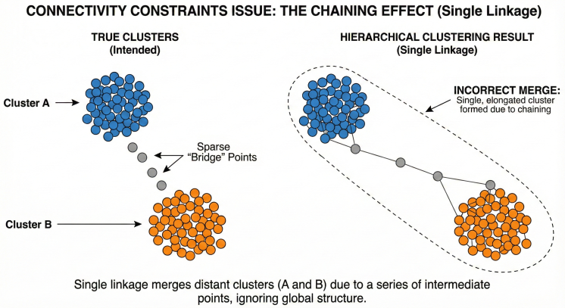

Clustering Application | Description and Examples
Customer Segmentation | Grouping customers based on buying behavior, demographics, or preferences to tailor marketing strategies.
Image Segmentation | Dividing images into meaningful regions for object detection or recognition (e.g., medical imaging).
Document Clustering | Organizing large text collections into topics or themes, aiding in information retrieval and summarization.
Anomaly Detection | Identifying outliers or fraud in data such as credit card transactions or network security.
Genomics and Bioinformatics | Clustering genes or proteins with similar functions or expressions to understand biological processes.
Market Research | Analyzing survey data to identify groups with similar opinions or behaviors.
Social Network Analysis | Detecting communities or clusters of users based on interaction patterns.
Recommender Systems | Grouping users or items to improve recommendation quality by finding similar preferences.
Earth Sciences | Classifying regions based on soil types, climate, or vegetation for environmental studies.
Health Care | Grouping patients with similar symptoms or diseases for personalized treatment plans.

